This master should be used by designers working on Port of Portland construction projects and by designers working for PDX tenants (“Tenants”). Usage notes highlight a few specific editing choices, however the entire section should be evaluated and edited to fit specific project needs.

SECTION 260553 – IDENTIFICATION FOR ELECTRICAL SYSTEMS
- GENERAL
      - DESCRIPTION
        - Clearly and properly identify the complete electrical system to indicate the loads served or the function of each item of equipment connected under this work.
Retain the labeling detail and sample referenced below only if there are no drawings; otherwise delete reference below and ensure the detail and sample are included in the drawings. Edit bracketed text as appropriate.
        - Provide conduit and cable identification as shown in the [drawings] [attached labeling detail].
Choose one of the following paragraphs. The first is for projects that include Section 260573, Electrical Systems Analysis, and the second is for small/tenant projects that don’t include Section 260573. Do not use both.
        - Provide arc flash warning labels in accordance with Section 260573, Electrical System Analysis.
        - Install Port-furnished arc flash warning labels.
      - REFERENCES
        - ANSI: American National Standards Institute
          - ANSI Z535.4: Product Safety Signs and Labels
        - NEC: National Electric Code
          - NEC Article 110: Requirements for Electrical Installation
        - OSHA: Occupational Safety and Health Administration
      - RELATED WORK SPECIFIED ELSEWHERE
        - Section 260573, Electrical System Analysis
- PRODUCTS
      - LABELS
        - Pre-Printed: Permanent material pre-printed with black on white, with adhesive backing. Brady, 3M, or equal.
        - Laminated Plastic: 3-ply laminated plastic, color as indicated, with 1/2-inch high white letters for low voltage and 1-inch high white letters for high voltage. Lamicoid, or equal.
        - Plastic Tape: Black or red with white letters, adhesive backing, field-printed with proper tool. Dymo-tape, or equal.
        - Marker Tape: Clear adhesive-backed tape with black letters, for device plates. Kroy, or equal.
        - Wire Markers: White with black numbers, adhesive-backed tape on dispenser roll. Brady, 3M, or equal.
        - Marker Pen: Black permanent marker suitable for writing on metallic surfaces.
        - Clearance Warning Tape: 2-inch wide self-adhesive vinyl type, black/yellow stripes. Seton, Brady, or equal.
- EXECUTION
      - LOW VOLTAGE SWITCHGEAR
        - Label all low voltage switchboards and protective devices with laminated plastic labels indicating the function or the load served.
        - Provide laminated plastic labels for all bussed spaces indicating the maximum ampere rating or size of future breaker or switch that may be installed in the space reserved.
      - BRANCH CIRCUIT PANELBOARDS
        - Indicate panel number, source, and if applicable, transformer number from which the panel is fed with laminated plastic labels attached to face trim. Indicate feeder source, feeder wire size, and feeder breaker or fuse size with laminated plastic labels on the inside of the panel door.
        - Provide new or updated panel schedules using the Port’s panel schedule template, available at https://www.portofportland.com/Business/MasterSpecs.
          - New panelboards shall be provided with protective, clear transparent covers, accurately accounting for every breaker installed, including spares.
          - A database of existing panel schedules is available online at https://portofportland.sharepoint.com/sites/EDE/Equipment%20Schedules/.
            - Existing panel schedules provided shall be verified with the panel schedules in the field and updated to reflect all known conditions at existing panelboards.
            - Provide hand-written markups to the printed copy of the panel schedule located in existing panelboards at the time of modification.
          - Panel schedules shall use the actual loads and room designations per the as-built conditions and updated within 30 days of work area completion. When room designations are modified, populate the room number reference table in the Port’s panel schedule template with old and new room designations. Provide a printed copy of the schedule at the panelboard and submit an electronic copy to the Port via email at electricalupdates@portofportland.com. Discard old copies of panel schedules in existing panelboards.
      - MOTOR CONTROL CENTERS
        - Label all motor control centers with laminated plastic labels.
        - Label all starters and breakers with factory-provided labels or laminated plastic labels indicating the function or the load served and location.
        - Provide pre-printed labels for all spaces.
      - TRANSFORMERS AND UPS
        - Label all transformers and UPS with laminated plastic labels indicating equipment number, source, and load.
      - EQUIPMENT
        - Label all disconnect switches, individual circuit breakers, security and communications panels, relays, contactors, time switches, and indicating equipment with laminated plastic labels indicating equipment number, source, and circuit number.
        - Where the controlling device is remote-mounted from the serving panel, include the serving panel designation and circuit number with additional plastic tape labels.
      - DEVICES
        - All receptacle plates shall be marked in black permanent marker tape on the face of the plate, with the receptacles panel and branch circuit designation. The identification shall be made with clear self-adhesive tape with black 10-point letters. Apply the tape at the top of the device plate.
        - Receptacles specified or noted on the drawings to be engraved, shall have the circuit information engraved in 3/16-inch letters on the front face of the plates. The alphabetic and numeric marking shall be made on the inside of the plate.
        - Receptacles connected to a GFCI-protected circuit downstream from the protecting device shall be labeled “GFCI Protected.”
      - CONDUIT AND CABLE
Choose one of the following two paragraphs. The first is for PDX tenant lease spaces only. The second is for Port spaces and all areas outside of tenant lease spaces. Do not use both.
        - Label all conduit runs and open cable wiring routed in cable tray or accessible ceiling spaces. Attach labels at the end of the conduit run and at least one per room. Place at entrances of all distribution panels, MCC, panelboards, etc.
        - Label all conduit runs and open cable wiring routed in cable tray or accessible ceiling spaces. Space labels a maximum of 50 feet apart and at least one per room. Place at entrances of all “J” boxes, distribution panels, MCC, panelboards, etc.
Edit bracketed text as appropriate.
        - Use laminated plastic labels as shown in the [drawings] [attached labeling detail].
        - Complete installation of labels prior to ceiling installation.
      - OUTLET, PULL, AND JUNCTION BOXES
        - Paint fire alarm and security access system outlets, pull, and junction boxes in accordance with the directions of their specific sections.
        - Label all pull boxes and junction boxes for fire alarm, security, surveillance, and communications systems with plastic tape, red with white letters. Where boxes are recessed in finished areas, mount label on inside of cover.
        - Label power junction boxes neatly by hand, indicating source and circuit number.
      - CONDUITS EXITING UNDERGROUND VAULTS
        - At each conduit entry and exit through an interior vault wall, provide an engraved brass label and fill the letters with contrasting enamel paint. The label shall identify each conduit and where it terminates. For example, the top northern conduit would be labeled “#1 to CVLTx,” where CVLTx is the end-point for that conduit run. The next lower conduit would be labeled sequentially as “#2 to CVLTx,” etc.
        - Provide corresponding labels at both ends of each conduit run including conduits that extend through interior walls of vaults, structures, or buildings.
        - Place the labels on the wall adjacent to each conduit. Secure the labels into the concrete with stainless steel screws and wall anchors that allow the label to be replaced if necessary.
      - UNDERGROUND VAULT DESIGNATIONS
        - Provide a label on each vault that indicates the assigned vault designation. Vault designations will be assigned by the Port.
        - Labels shall be constructed from engraved stainless steel or brass. Text height shall be a minimum 1 inch tall. Adjust the size of the label to include all the characters in the designation. Use stainless steel fasteners to secure the labels. Bead welding on top of the manhole cover is an acceptable alternative.
        - Locate the label on the top of the vault, on the manhole cover or lid, or in another location coordinated with the Port. Where the vault will be covered, place label on the manhole cover or other visible location.
      - SYSTEMS
        - Complex control circuits may utilize any combination of colors with each conductor identified throughout, using wrap-around numbers or letters. Use the number or letters shown where the drawings or operation and maintenance data indicate wiring identification.
        - Label the fire alarm and communication equipment zones, controls, indicators, etc., with pre-printed labels or indicators appropriate for the equipment installed, as supplied or recommended by the equipment manufacturer.
        - Label each end of pull wires left in empty conduits with tags or tape indicating location of other end of wire.
      - CLEARANCE WARNING TAPE
        - Affix to floor clearance warning tape to define area in front and around electrical switchgear, panels, and motor control centers. Type layout shall conform to the requirements of NEC 110 and OSHA.
        - Remove debris and clean area prior to installing tape.
Choose one of the following two articles. The first is for projects that include Section 260573, and the second is for smaller/tenant projects that do not include Section 260573. Do not use both.
      - ARC FLASH WARNING LABELS
        - Provide pre-printed arc flash and shock hazard warning labels for switchgear, transformers, panel boards, industrial control panels, motor controllers (including those furnished with mechanical equipment), motor control centers, safety switches, automatic transfer switches, UPS, and other equipment as required by NEC and OSHA. See Section 260573 for additional requirements.
        - Warning labels shall comply with ANSI Z535.4. Color in top part of sign shall be ANSI “safety orange.” All lettering on label shall be black.
        - Labels shall be self-adhesive. Outdoor labels shall be suitable for high-UV environment.
        - Label dimension shall be 4 inches by 6 inches wide.
      - ARC FLASH WARNING LABELS
        - A minimum of 4 weeks prior to anticipated substantial completion, submit the following information to the Port for the arc flash analysis on newly installed equipment:
          - Feeder sizes for each piece of equipment including feeder type, length, configuration, and raceway type in which feeder is installed.
          - Overcurrent protection equipment brand name, model number, and any breaker settings and/or fuse sizes. Provide information for all overcurrent devices including Port-owned equipment feeding new feeders and newly installed equipment.
          - Equipment AIC rating.
        - The Contractor shall install labels furnished by the Port.

Retain the graphics below only if there are no drawings. Otherwise delete and include the graphics in the drawings.
PORT STANDARDS FOR ELECTRICAL EQUIPMENT IDENTIFICATION
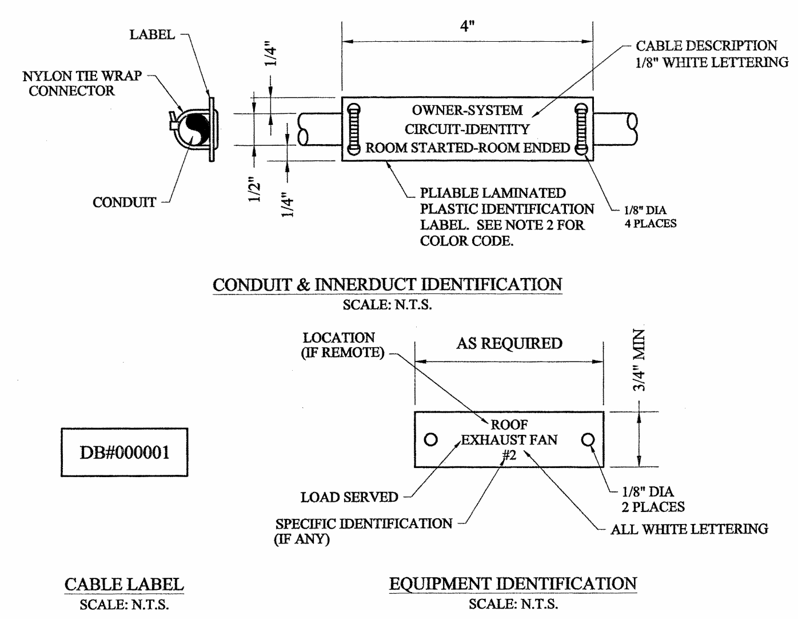
NOTES:
1. Use laminated labels at all interior and protected locations. Use professionally engraved, white enamel filled brass labels in all areas exposed to the weather and/or sunlight, and in environment air handling spaces.
2. Color code for labels shall be as follows:
Port | Blue
FAA | Yellow
Airlines | Green
Telco | Red
Other Tenants | Black
Emergency and Fire Alarm | White with Red Letters
3. Install conduit and innerduct labels at each end of the conduit run, at entrances of all duct banks, distribution panels, motor control centers, panel boards, etc. Provide a minimum of one label per room or space.
4. Install equipment labels with stainless steel #4 screws.
5. System examples: Power, Fire Alarm, HVAC, Communications, Signal, Telephone, Revenue Control
6. Label cables with preprinted label. Labels shall wrap around and shall have a reference number. At a minimum, label the cable at the cable start and end terminals, at intermediate points in runs where cable leaves a cable tray, and at all intermediate junction boxes and lay down locations.
7. Complete installation of labels prior to ceiling installation.
END OF SECTION 260553

