This master should be used by designers working on Port of Portland construction projects and by designers working for PDX tenants (“Tenants”). Usage notes highlight a few specific editing choices, however the entire section should be evaluated and edited to fit specific project needs.

SECTION 270553 – IDENTIFICATION FOR TELECOMMUNICATION SYSTEMS
- GENERAL
      - DESCRIPTION
        - This section describes labeling requirements for a complete telecommunications system, including the following.
          - Horizontal link/cable.
          - Telecommunication outlets.
          - Telecommunications hardware.
          - Riser/backbone cable.
      - RELATED WORK SPECIFIED ELSEWHERE
        - Section 260500, Common Work Results for Electrical Systems
        - Section 260553, Identification for Electrical Systems
        - Section 271000, Structured Cabling
- PRODUCTS
      - LABELS
        - Pre-Printed: Permanent material pre-printed with black on white, with adhesive backing. Brady, 3M, or equal. No Dymo-tape or hand-written labels will be allowed. For use at the following locations:
          - Telecommunication outlet faceplates.
          - Individual horizontal cables.
          - Rack-unit (RU) identification of network room equipment racks.
          - Fiber optic distribution units (FODU).
          - Protector blocks.
        - Laminated Plastic: 3-ply laminated plastic, professionally engraved. Use white enamel filled brass labels in all areas exposed to weather and/or sunlight, and in environmental air handling spaces. Font shall be Arial capital letters. Attach labels using appropriate adhesive glue and/or nylon tie wrap connectors. Required sizes and colors are as follows:
          - Network Room Equipment Racks: 1-inch high and 5-inches long with a white background and 1/2-inch high black letters.
          - Riser/Backbone Cable: 1-inch high and 4-inches long with a blue background and 1/8-inch high white letters. The label shall have two lines. The first line shall read “Port Telco.” The second line shall indicate the appropriate cable identifier.
- EXECUTION
      - LABEL INSTALLATION
        - Horizontal Link/Cable:
          - Label each horizontal link/cable at the rear of both the outlet and patch panel locations using the appropriate cable name as indicated.
          - At the outlet location, label the cable at 2 inches from the termination point. This will be visible by removing the outlet cover.
          - At the patch panel location, label the cable on a visible part of the cable within 4 inches of the termination point.
        - Telecommunication Outlet Faceplates:
          - Label each faceplate appropriately as indicated. Affix the label to the labeling area at the top of the faceplate.
          - The port ID area of the faceplate shall reflect the equipment row, network rack number, patch panel ID and patch panel port number.
        - Riser/Backbone Cable:
          - Every fiber optic and copper riser/backbone cable sheath shall be labeled with the appropriate cable name.
          - Where cables are placed in an exposed manner, labels shall be placed at a minimum of every 100 feet. If a room is utilized as a routing space, the cable shall be labeled where it enters and exits the room.
          - Cables shall be labeled at entrances to, or exits from, cable trays, riser sleeves, duct banks, junction boxes, and on both sides of a splice point.
        - Network Rack:
          - Each network rack shall be labeled with plastic laminated labels indicating the rack number. Affix the label at the top/middle of the rack.
          - Each patch panel and/or termination block mounted within each rack shall be labeled with pre-printed labels. The label designation shall indicate the alphabetic character that represents the associated RU number of the equipment being placed. Mount the label on the left most rack rail immediately adjacent to the top left corner of the patch panel/termination block that is being identified.
        - FODU/Termination Block:
          - Label each FODU/termination block on its front surface with the appropriate cable name relative to the fiber optic and/or copper cable terminated on the unit.
          - Affix the fiber optic cable name label to the FODU on the bottom left-hand corner of the unit’s front panel. Where more than one cable is terminated in the FODU the subsequent cable name labels will be placed so that they align above each other.
          - Affix the cable name label to the termination block on the top left-hand corner of the block’s terminal strip cover.
      - LABEL NAMING CONVENTION
        - Horizontal Link/Cable

Example: TRM.3X-A5B01
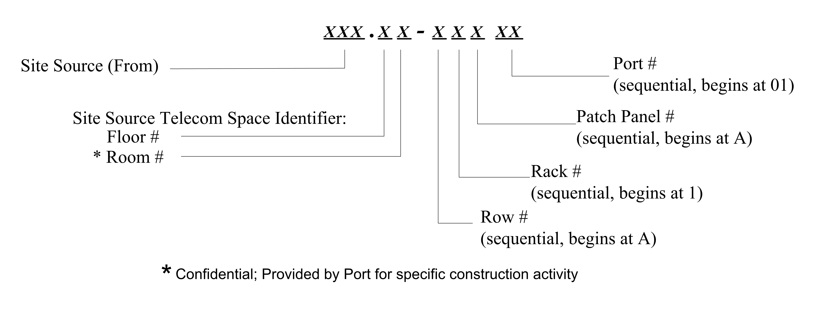
        - Telecommunication Outlet Faceplate Label
          - For the labeling area at the top of the faceplate:

Example: TRM.3X
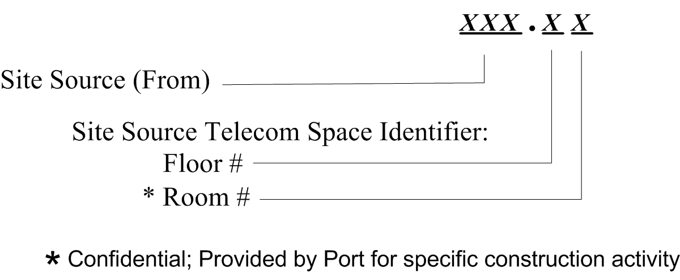

          - For the port ID area of the faceplate:

Examples: 4-port faceplate, A5B01, A5B02, A5B03, A5B04 (each a minimum of 5 digits)
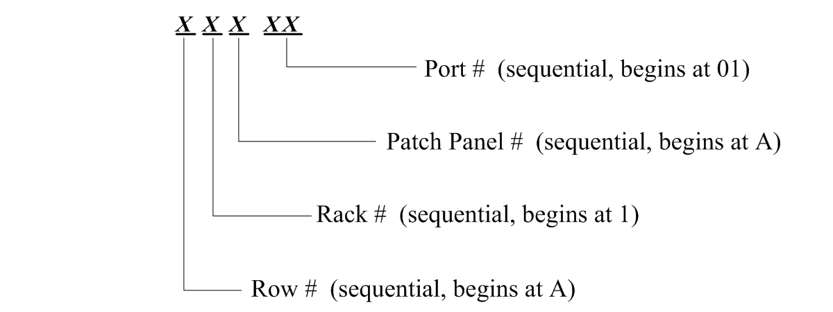
        - Riser/Backbone Cable (No Splice Case)

Example: TRM.1X/TRM.3X-F-01M
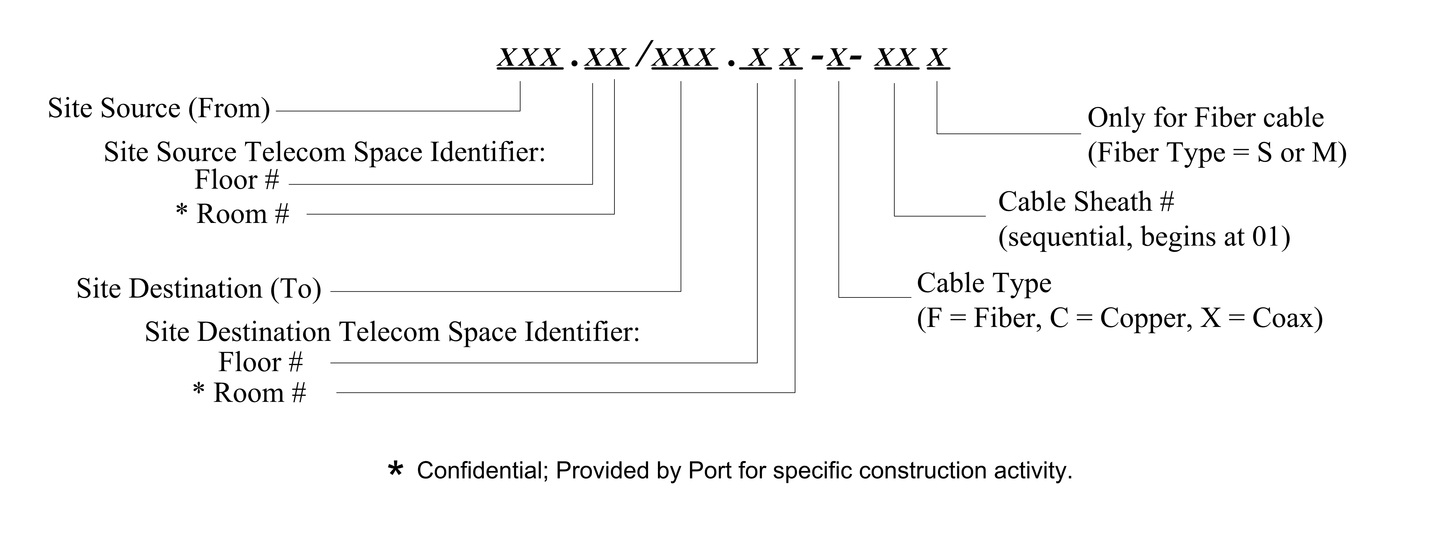
        - Riser/Backbone Cable Identifier w/ Splice Case

Example: TRM.1X/TRM.3X.Z1-F-01M
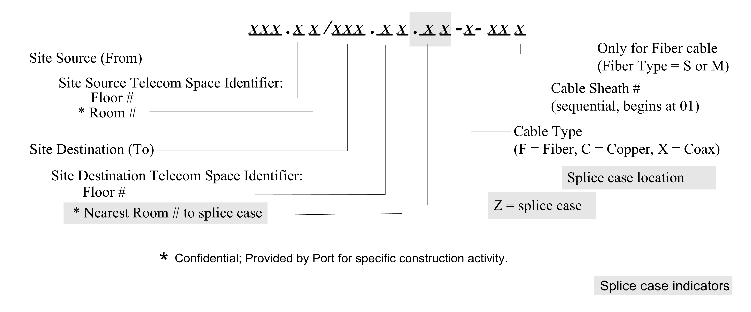
The following site identifier locations are specific to a geographical area. Delete those locations not associated or required for the specific project.
      - SITE IDENTIFIERS
        - PDX
Site Name | Abbreviation
Fire Dept / ARFF  Airfield Gate  Airport Way  Bus Offices  Concourse A  Concourse B  Concourse C  Concourse D  Concourse E  Commercial Roadway Lower  Commercial Roadway Upper  SIDA Checkpoints  Construction Trailers  Central Utility Plant  Deicing Pump Stations  Fiber Hub Enclosure  Ground Run-up Enclosure  IT Hut (North)  Employee Lot (Alderwood)  Economy Lot (Red & Blue)  Ground Transportation Lot  Employee Lot (HQ)  Long Term Lot  Maintenance Annex  Maintenance  North Cargo  Passenger Boarding Bridge Concourse B  Passenger Boarding Bridge Concourse C  Passenger Boarding Bridge Concourse D  Passenger Boarding Bridge Concourse E  P1 - Parking Garage  P2 - Parking Garage  HQ Headquarters  Quick Turn Around (Car Wash)  DMS Reader Airport Way  DMS Reader 82nd Ave  South Cargo  South IT Hut  Sewage Pump Station  Taxi Hold Area  Tower  Toll Plaza  Main Terminal Bldg | AFD  AFG  APW  BOF  CCA  CCB  CCC  CCD  CCE  CML  CMU  CPS  CTR  CUP  DPS  FHE  GRE  HUT  LAR  LEA  LGT  LHQ  LLT  MXA  MXF  NCR  PBB  PBC  PBD  PBE  PGA  PGB  POP  QTA  RAW  RND  SCR  SIH  SPS  TAX  TOW  TPL  TRM
        - T6 Marine Terminal
Site Name | Abbreviation
Marine Admin | ADM
Gear Locker | GLK
Electric Shop | ELS
CY Gate | CYG
Entry Lane | ELN
Berth 601 | B01
Berth 603 | B03
Berth 604 | B04
Berth 605 | B05
Berth 607 | B07
Container Dist Center | CDC
Trailer, Hiring Hall | TL1
Trailer, Security | TL2
Trailer, Auto Dock | TL3
Block House | BLK
Canopy | CPY
OCR Shed | OCR
Radiation Portal | RAD
Guard Shack, Main | GS1
Guard Shack, Auto Dock | GS2
Guard Shack, Abandoned | GS3

        - T4 Marine Terminal
Site Name | Abbreviation
Marine Admin | ADM
Gear Locker | GLK
Electric Shop | ELS

        - Marine Facility Maintenance
Site Name | Abbreviation
Marine Facility Maintenance | MFM

        - Port of Portland Headquarters Building
Site Name | Abbreviation
HQ Headquarters | POP

        - Hillsboro Airport
Site Name | Abbreviation
Terminal | TRM
Maintenance | MXF

A telecom space identifier location is always associated with its specific site identifier location. Delete those locations not associated or required for the specific project.
      - TELECOM SPACE IDENTIFIERS
        - PDX
Site Name | Floor No. | Room No. * | Telecom Space Identifier *
TRM | 1 | T1xxx | 1X
 | 2 | T2xxx | 2X
 | 3 | T3xxx | 2X
CCA | 1 | A1xxx | 1X
 | 2 | A2xxx | 2X
CCB | 1 | B1xxx | 1X
CCC | Tunnel | C-0x | 0X
 | 1 | C1xxx | 1X
 | 2 | C2xxx | 2X
 | 3 | C3xxx | 3X
CCD | Tunnel | D-0x | 0X
 | 1 | D1xxx | 1X
 | 2 | D2xxx | 2X
 | 3 | D3xxx | 3X
CCE | Tunnel | E-0x | 0X
 | 1 | E1xxx | 1X
 | 3 | E3xxx | 3X
PGA | Tunnel | P0xxx | 0X
 | 8 | P8xxx | 8X
CUP | - | Room Name | 1X
MXF | 1 | M1xx | 1X
 | 2 | M2xx | 2X
DPS | - | PS-X | 1X
LLT | - | Room Name | 1X
CPS | - | Room Name | 1X
TPL | - | Room Name | 1X

* There are multiple room numbers with associated telecom space identifiers not shown for security reasons. Information will be provided as required for specific construction activity.

        - T6 Terminal
Site Name | Floor No. | Room No.  (If Applicable) | Telecom Space Identifier
ADM | 1 | - | 1X
 | 2 | - | 2X
 | 3 | - | 3X
GLK | 1 | - | 1X
 | 2 | - | 2X
ELS | 1 | - | 1X
 | 2 | - | 2X
CYG | - | - | 1X
ELN | - | - | 1X
B01 | 1 | - | 1X
 | 2 | - | 2X
B03 | 1 | - | 1X
 | 2 | - | 2X
B04 | 1 | - | 1X
 | 2 | - | 2X
B05 | 1 | - | 1X
 | 2 | - | 2X
B07 | 1 | - | 1X
 | 2 | - | 2X
CDC | 1 | - | 1X
 | 2 | - | 2X
TL1 | - | - | 1X
TL2 | - | - | 1X
TL3 | - | - | 1X
BLK | - | - | 1X
CPY | - | - | 1X
OCR | - | - | 1X
RAD | - | - | 1X
GS1 | - | - | 1X
GS2 | - | - | 1X
GS3 | - | - | 1X

        - T4 Terminal
Site Name | Floor No. | Room No.  (If Applicable) | Telecom Space Identifier
ADM | - | - | 1X
GLK |  | - | 1X
ELS | - | - | 1X

        - Marine Facility Maintenance
Site Name | Floor No. | Room No.  (If Applicable) | Telecom Space Identifier
MFM | 1 | - | 1X
 | 2 | - | 2X

        - Port of Portland Headquarters Building
Site Name | Floor No. | Room No.  (If Applicable) | Telecom Space Identifier
POP | 8 | H8343 (East) | 8A
 | 8 | H8422 (West) | 8J
 | 8 | H8339 (Data Center) | 8F
 | 8 | H8318 (It Tech Lab) | 8G
 | 8 | H8340 (Ntwk Test/PBX) | 8L
 | 8 | H8119 (Projector Rm) | 8P
 | 8 | H8302 (EOC) | 8S
 | 8 | Splice in Data Center | 8Z1
 | 9 | H9308 (East) | 9A
 | 9 | H9421 (West) | 9J
 | 9 | H9337 (Tech Lab) | 9L
 | 9 | H9339 (Radio Test) | 9C
 | 10 | H10201 (East) | 10A
 | 10 | H10330 (West) | 10J
        - Hillsboro Airport
Site Name | Floor No. | Room No.  (If Applicable) | Telecom Space Identifier
TRM | 1 | T1xx | 1X
TRM | 2 | T2xx | 2X
MXF | 1 | T1xx | 1X
MXF | 2 | T2xx | 2X
      - OPTIONAL IDENTIFIERS
        - Use the following where required on riser/backbone labels.
C | Copper
F | Fiber
X | Coax
W | Wireless
M | Multimode
S | Single Mode
Z | Splice Case

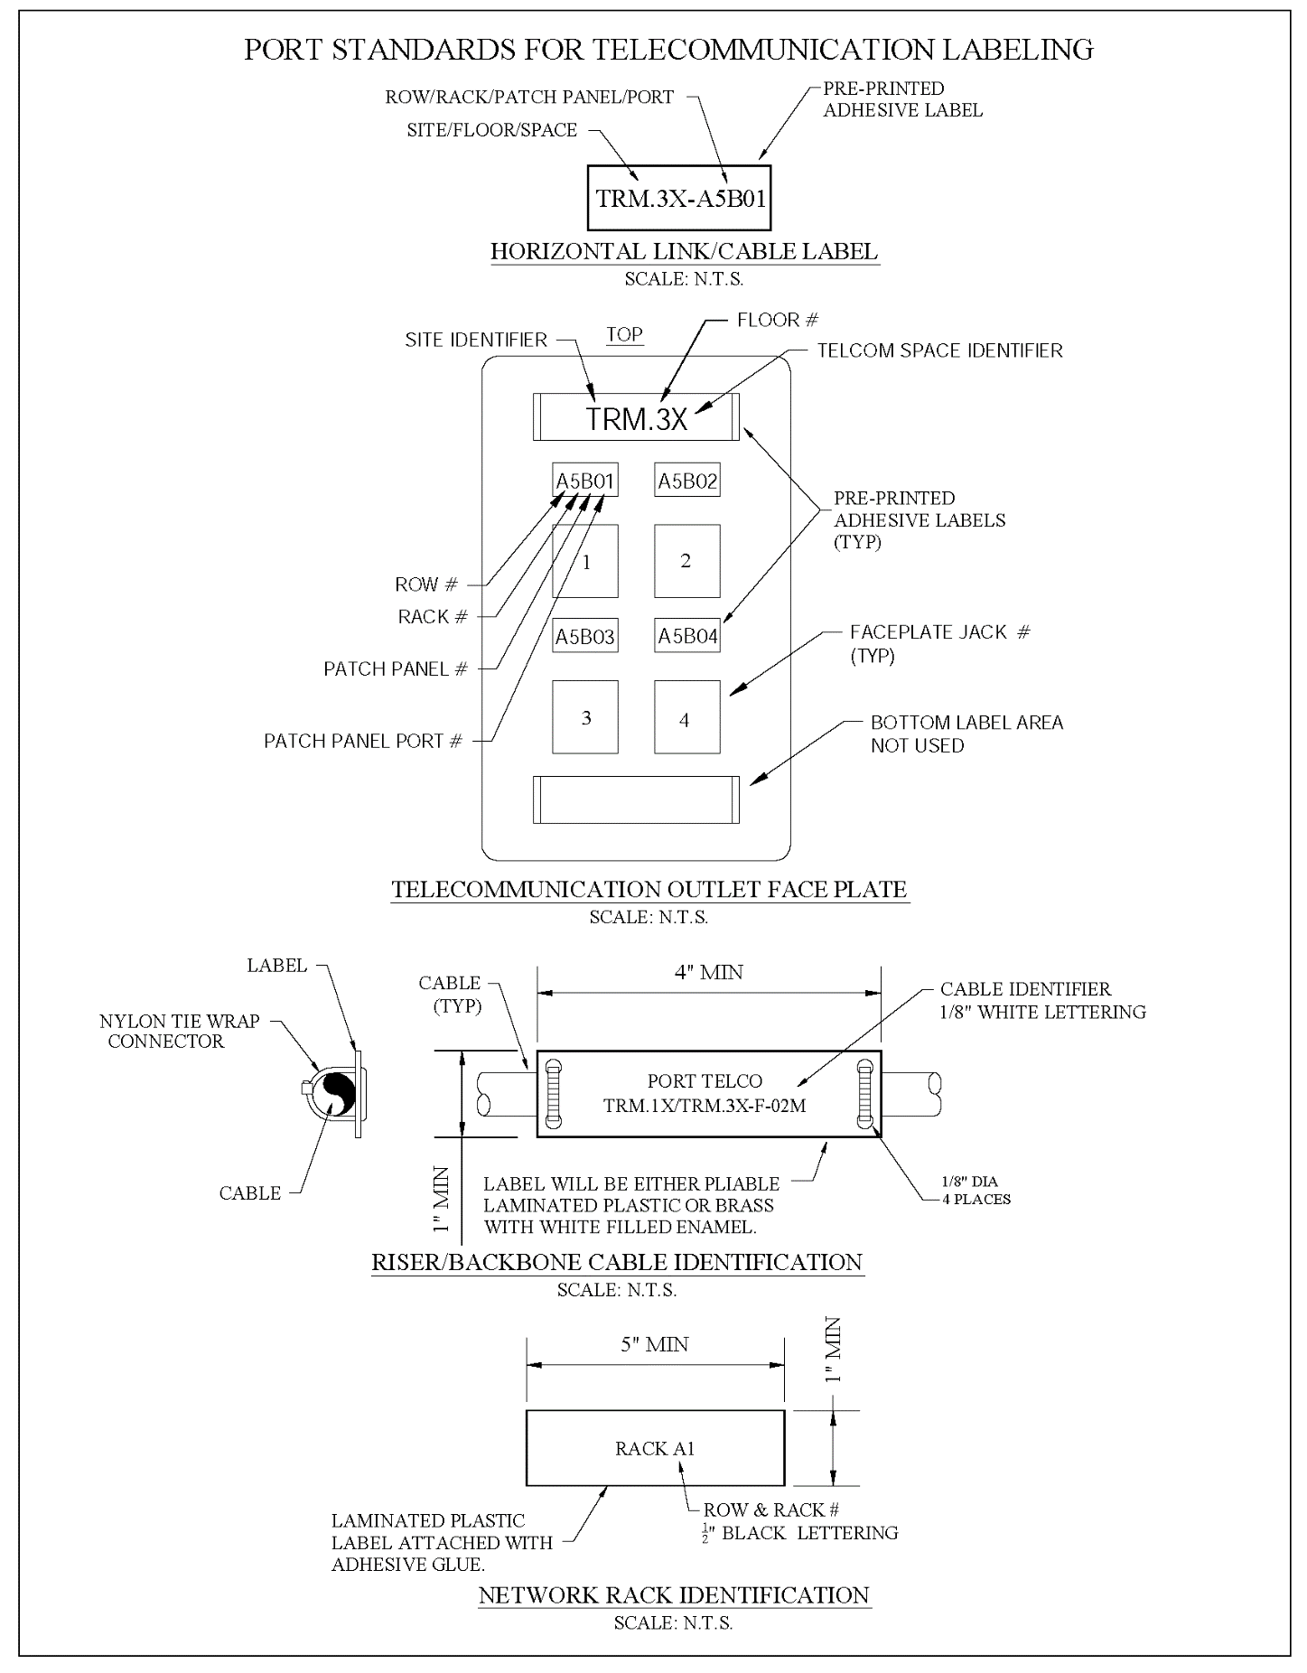
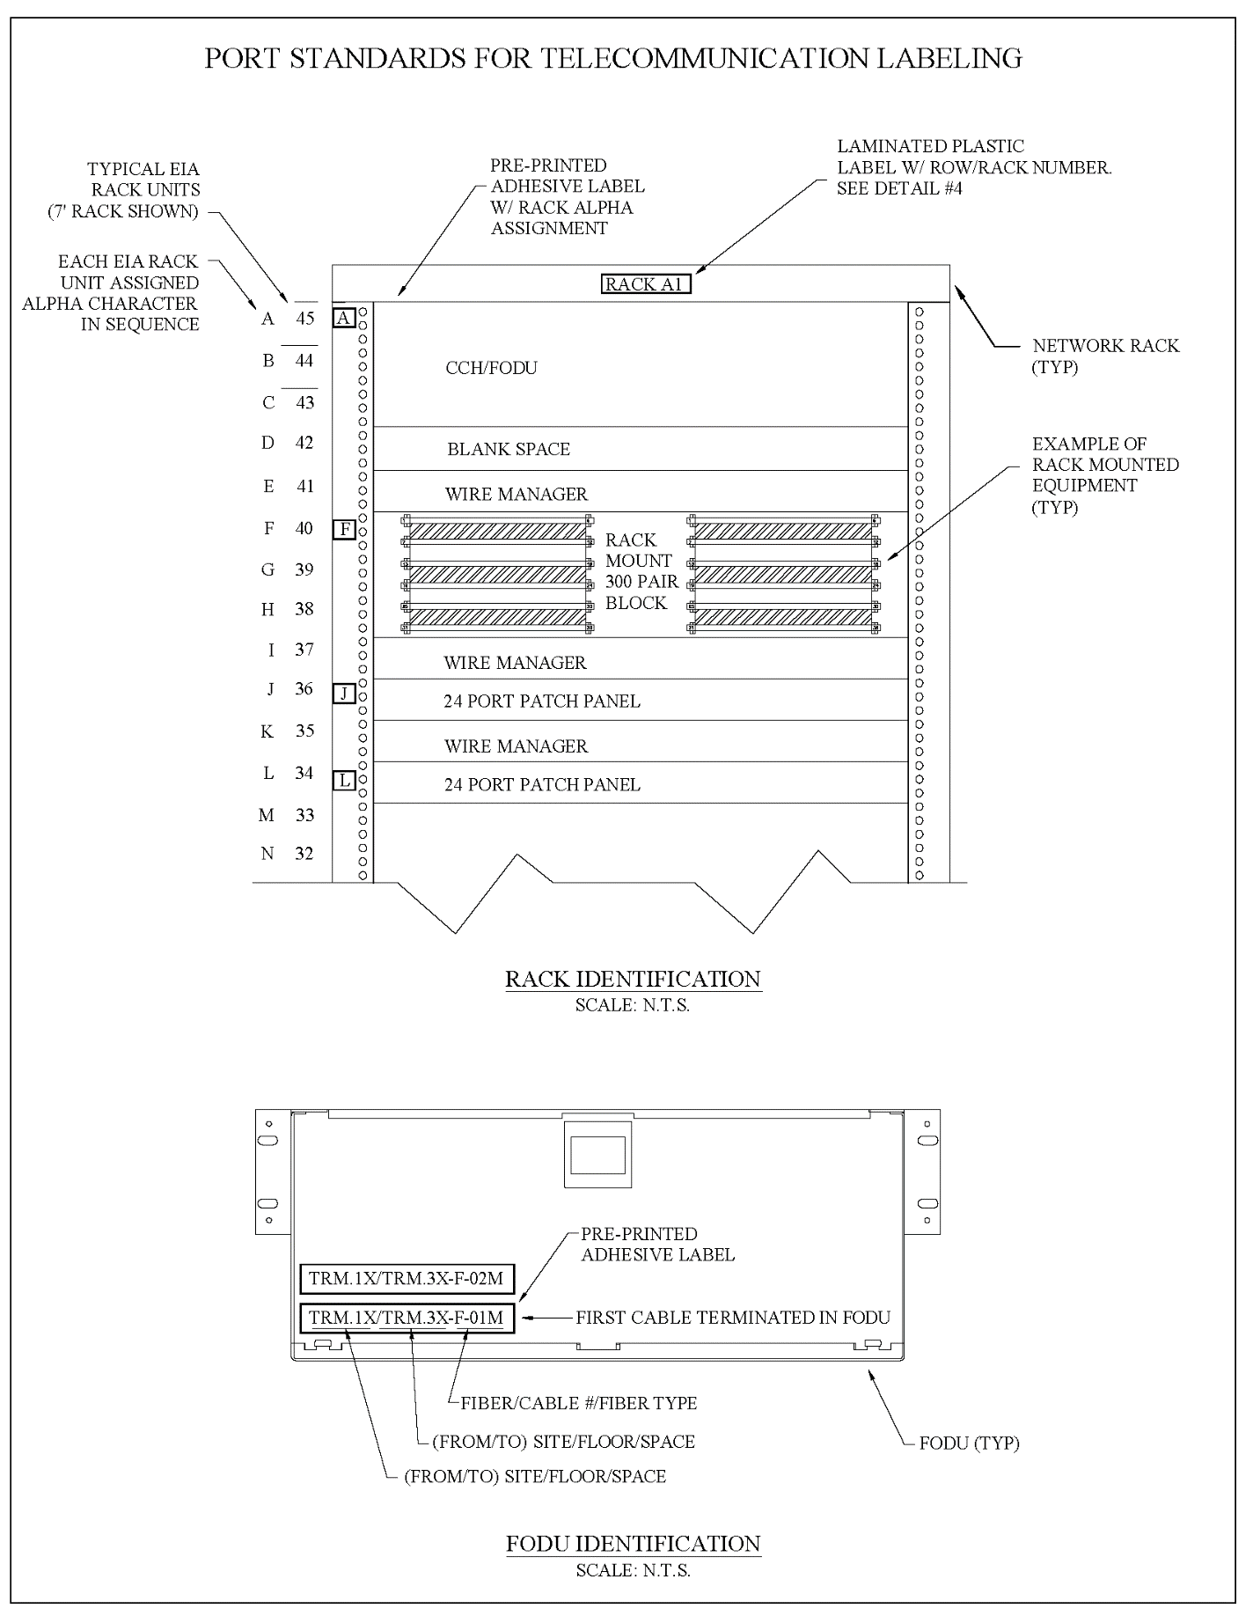
END OF SECTION 270553

